Adding New Column

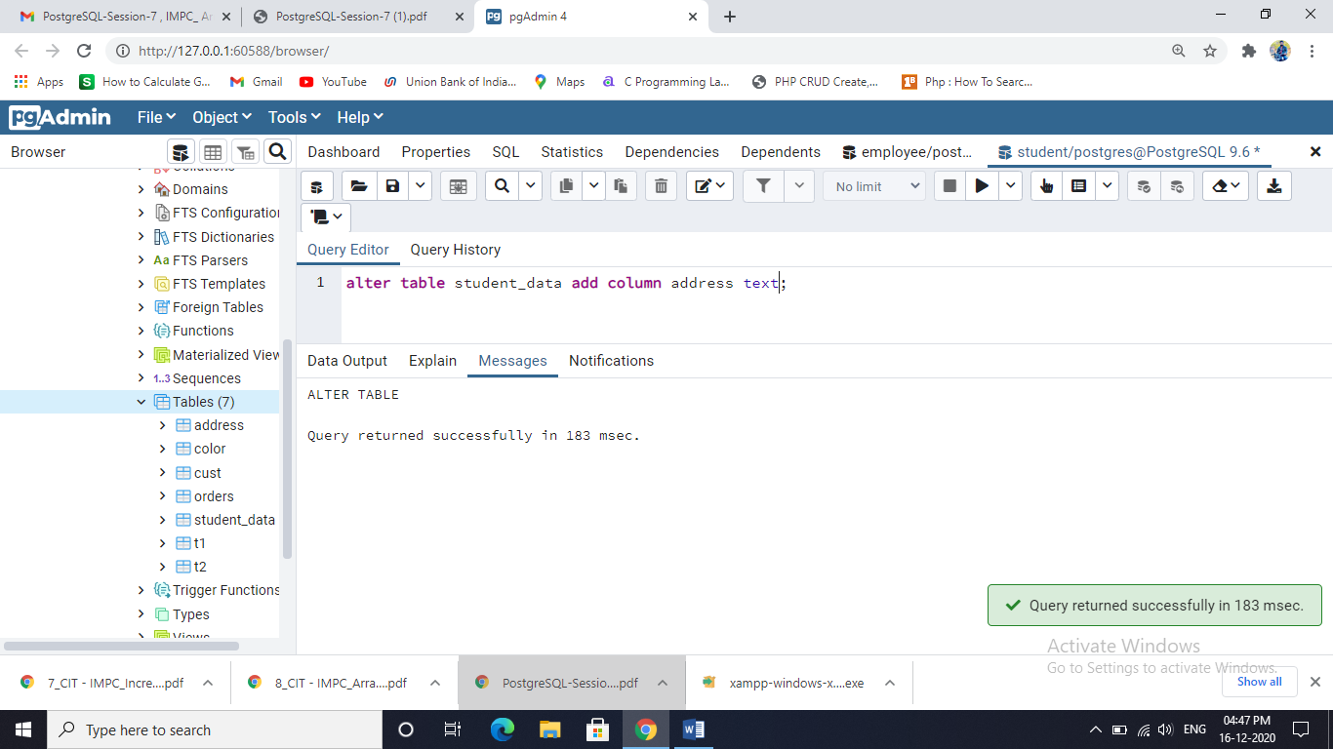alter table student_data add column address text;

Drop Column

alter table student_data drop column address;

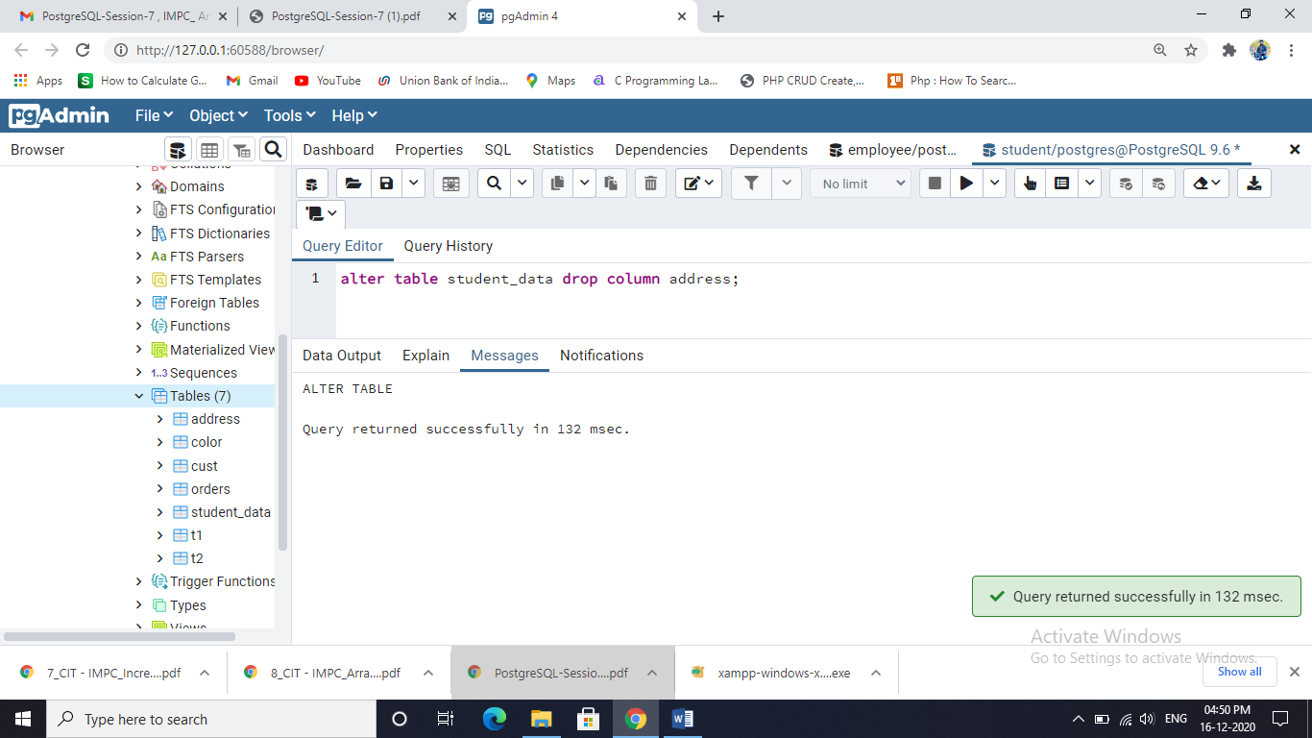

Rename Column Name:

alter table student_data Rename column p_year to pass_year;

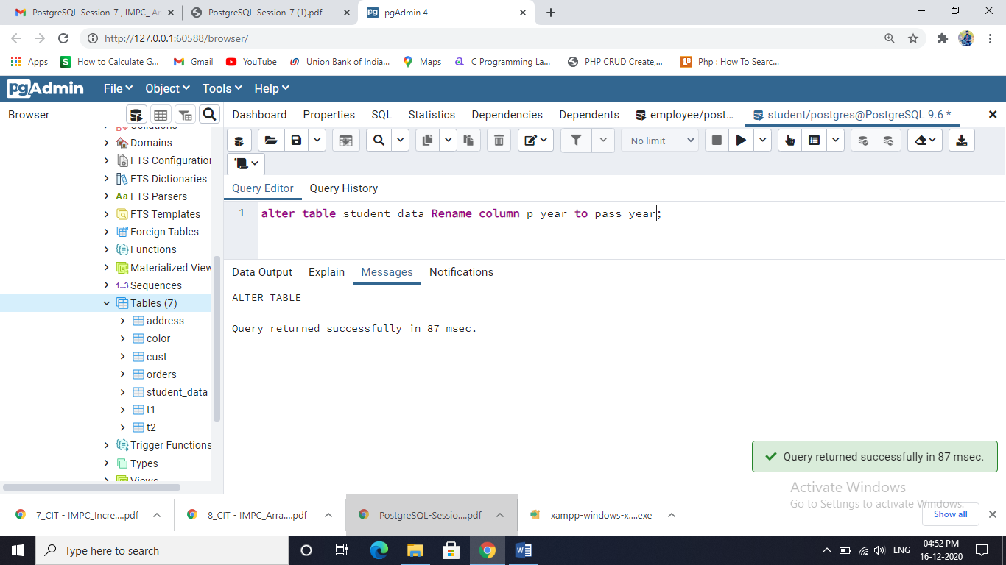

Set Default

alter table student_data alter column address set default 'ahmednagar';

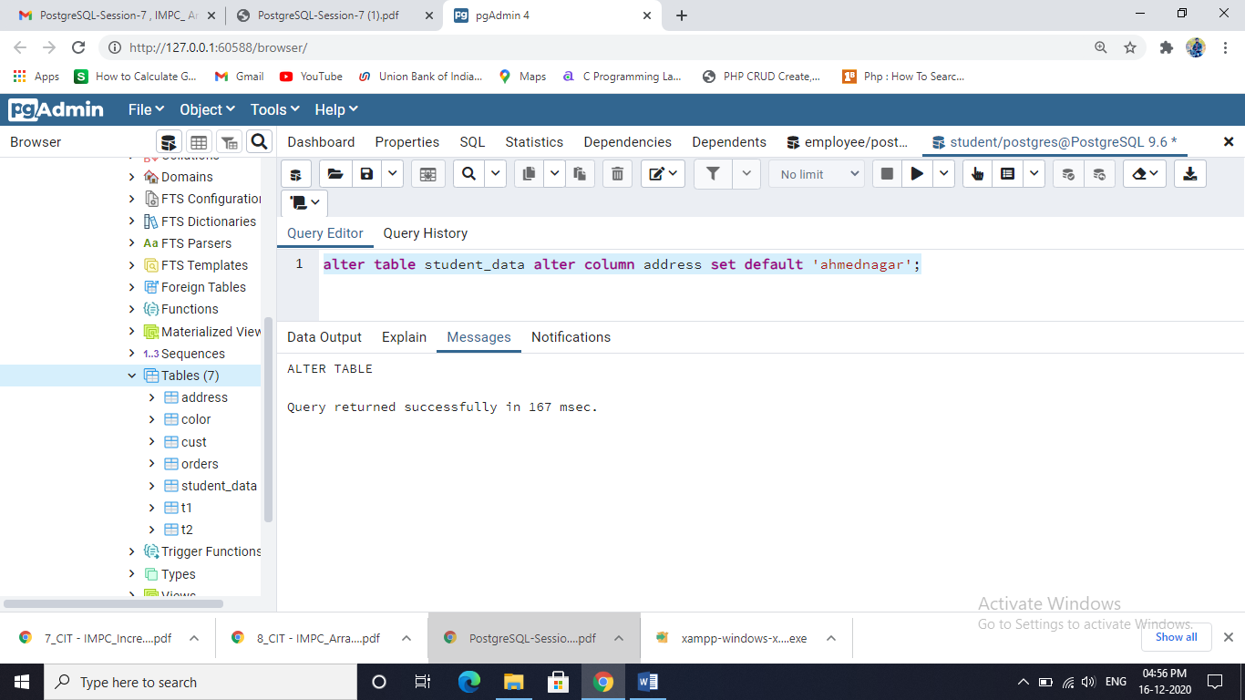

insert into student_data values(7,'ashish','gore','agi@gmail.com',52,2016);

select * from student_data;

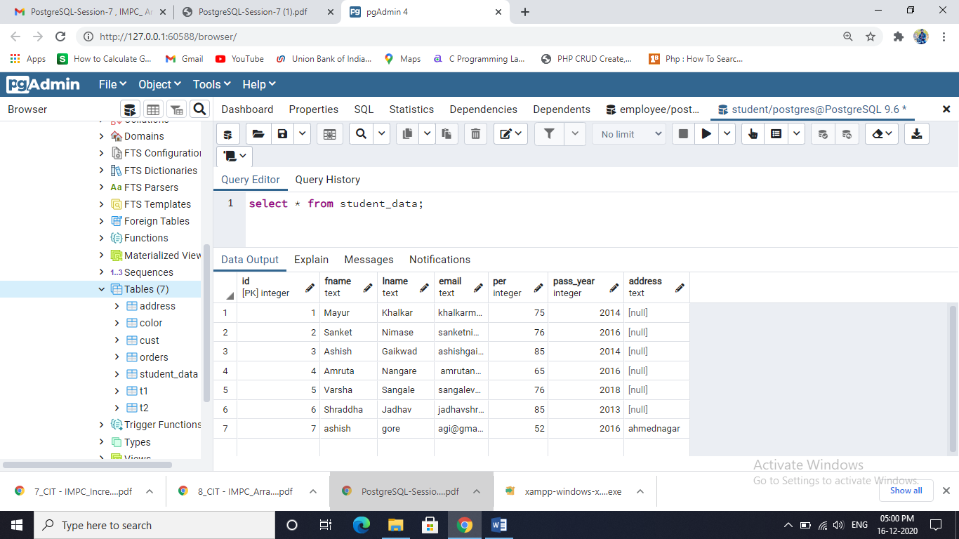

Add Check

alter table student_data add check (address in('ahmednagar','nashik'));

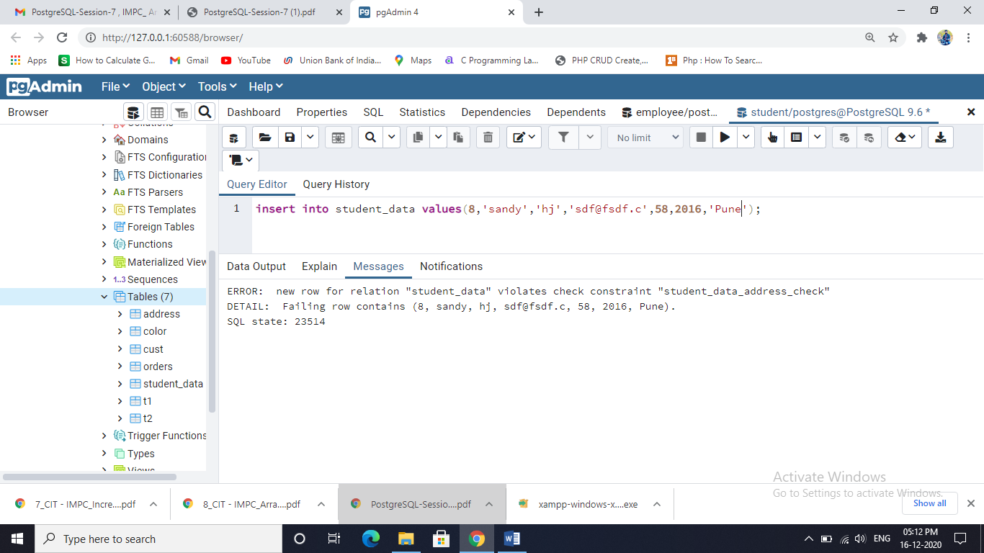

ALTER TABLE IF EXISTS

alter table if exists t1 rename to t3;

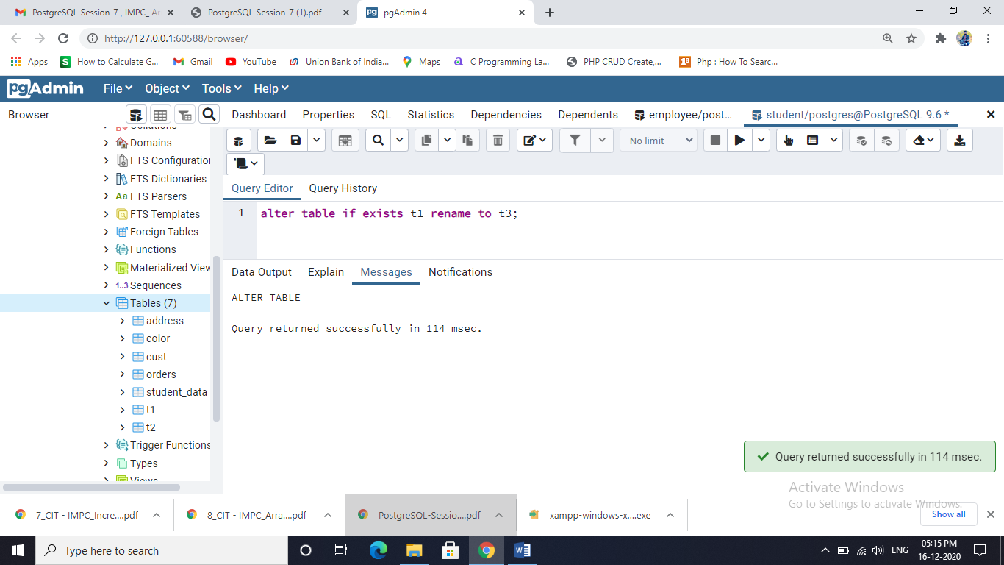

Creating Suppliers table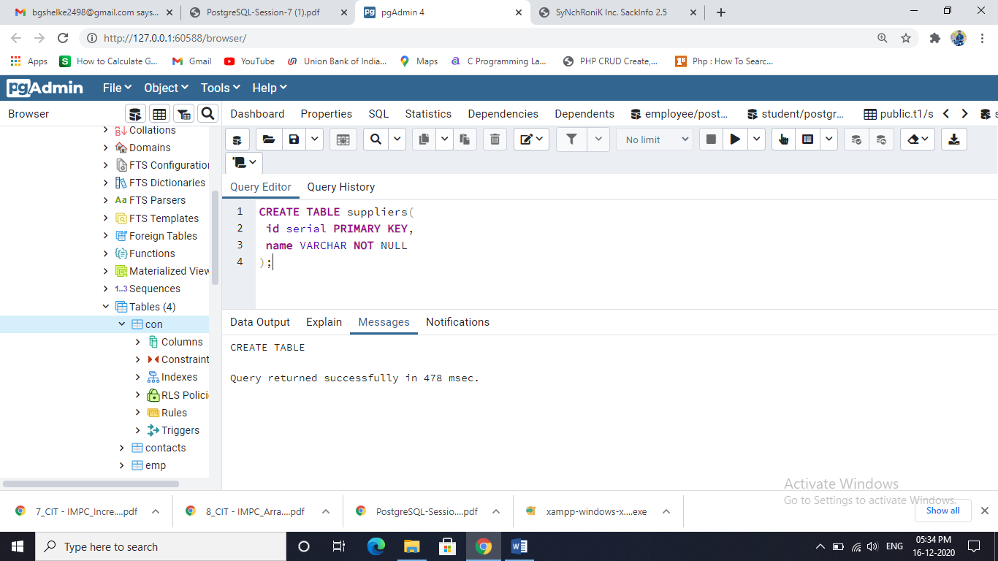

Creating Suppliers_group table

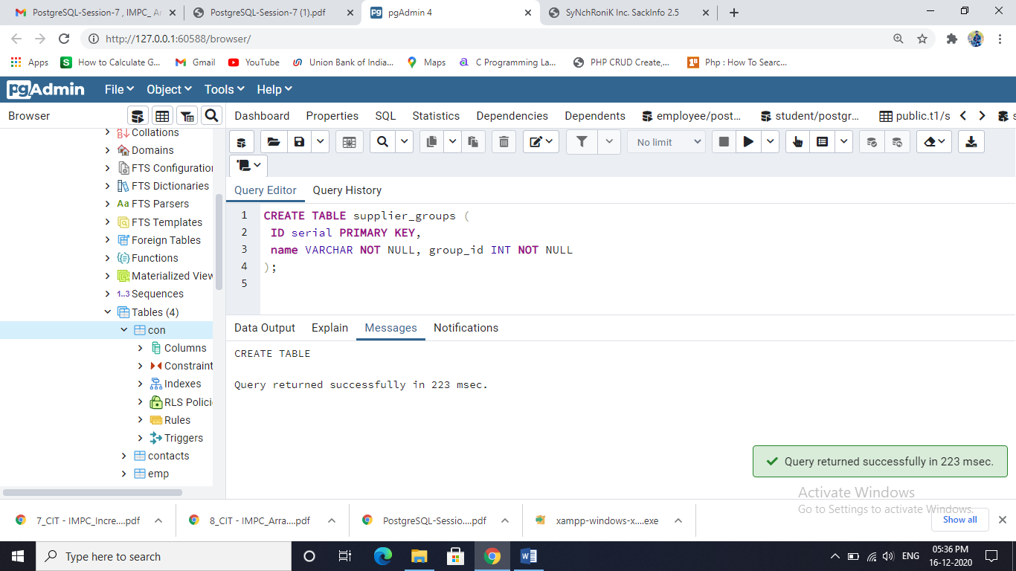

Foreign Key :

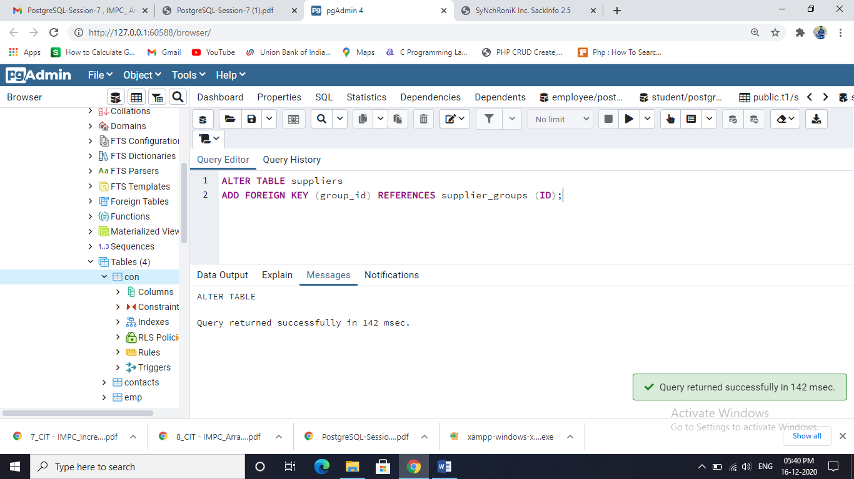

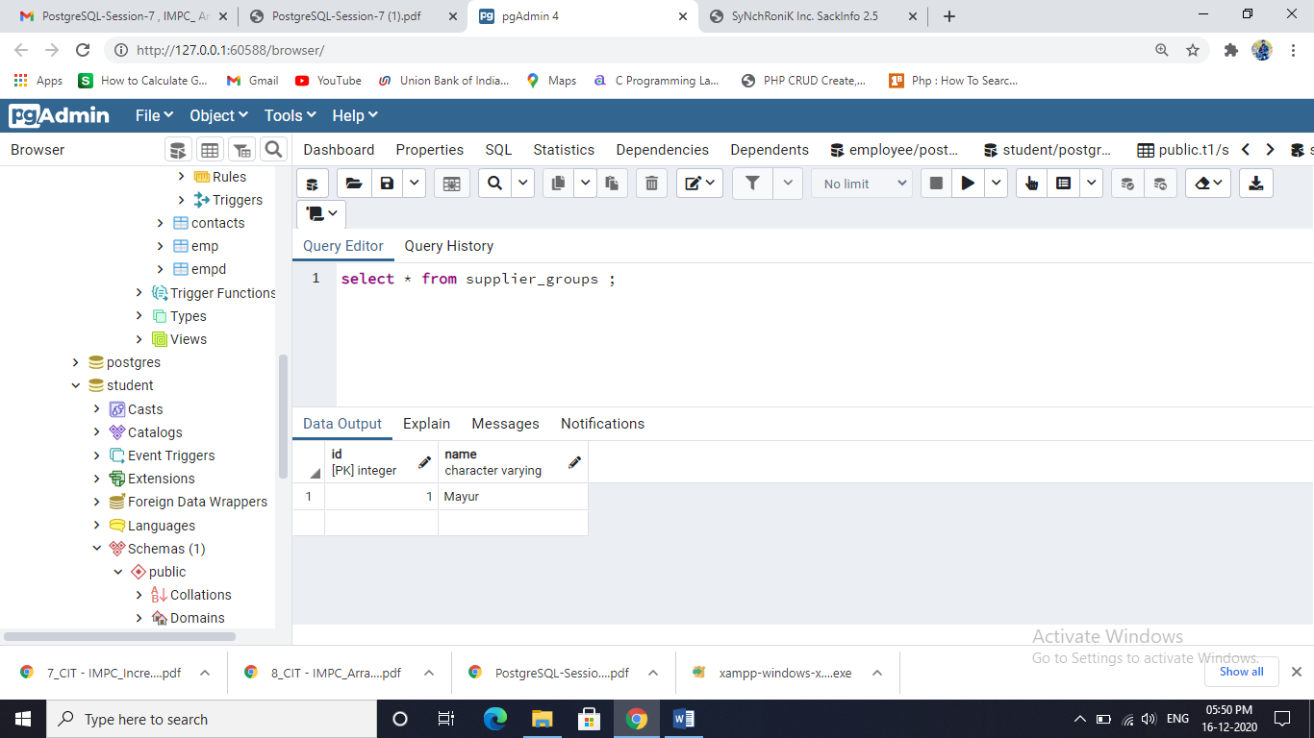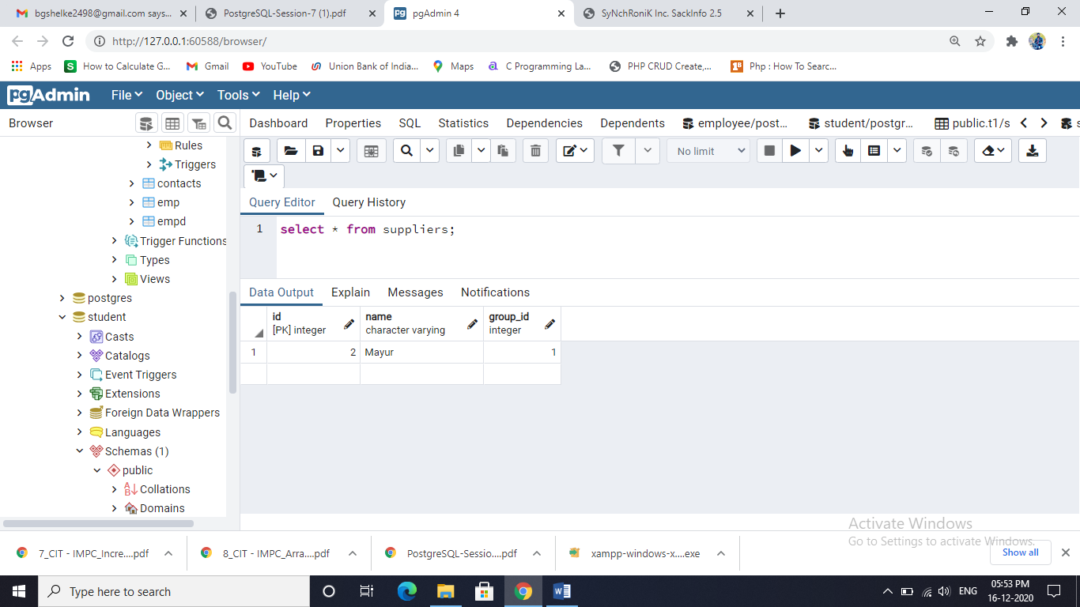

Creating View

CREATE VIEW Contact_View AS SELECT ename, job FROM emp WHERE empid in(1,2,3,4);

